Object Detection

Key Concepts

* Bounding Box: A rectangle around the detected object, defined by (x, y, width, height).
* Annotations: Labeled data used for training object detection models.
* Confidence Score: A probability indicating how likely an object is present.
* Intersection over Union (IoU): Measures the overlap between predicted and ground-truth boxes.

**Diagram: Bounding Box and IoU**

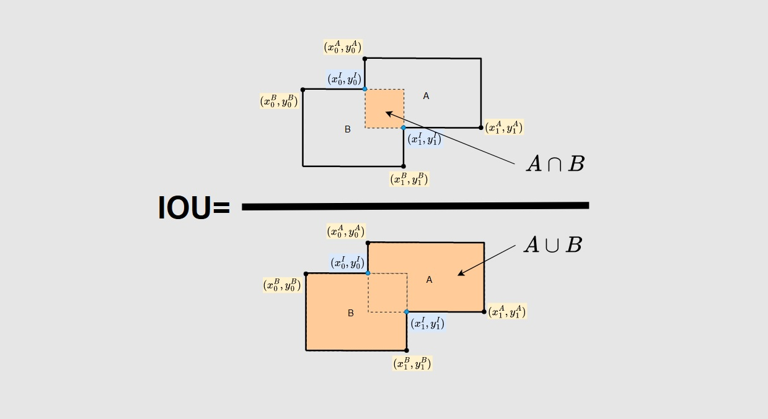

Common Object Detection Algorithms

1. R-CNN (Regions with CNNs): Uses region proposals and CNNs for classification.
2. Fast R-CNN: Optimizes R-CNN by sharing convolutional features.
3. Faster R-CNN: Uses a Region Proposal Network (RPN) for speed improvement.
4. SSD (Single Shot MultiBox Detector): Detects objects in a single pass, making it faster.
5. YOLO (You Only Look Once): Predicts bounding boxes and class probabilities in one step, balancing speed and accuracy.

**Flowchart: Object Detection Algorithm Comparison**

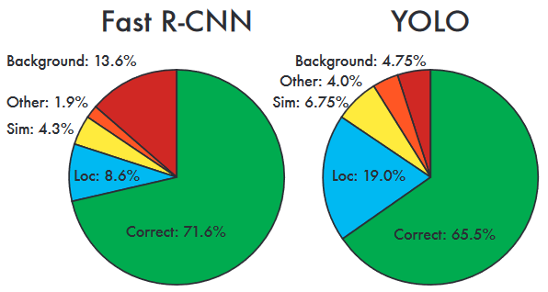

**Steps in Object Detection**

1. Data Collection & Annotation: Gather labeled images with bounding boxes.
2. Data Preprocessing: Resize, normalize, and augment images.
3. Model Selection: Choose between pre-trained models (e.g., SSD, YOLO) or custom training.
4. Training & Validation: Train the model using a dataset and evaluate performance.
5. Inference & Post-processing: Run detection on new images and apply non-max suppression.

**Common Challenges & Solutions**

* Class Imbalance → Use weighted loss functions or data augmentation.
* Overfitting → Apply dropout, regularization, or more diverse training data.
* Slow Inference Time → Use model quantization, pruning, or lighter architectures.
* Poor Localization → Optimize anchor box sizes and loss functions.

**Tools & Libraries**

* TensorFlow & Keras: Deep learning frameworks for training object detection models.
* OpenCV: Computer vision library for image processing and detection.
* PyTorch: Alternative deep learning framework with dynamic computation graphs.
* **Installation Examples:**

pip install tensorflow opencv-python torch torchvision

* **Basic Usage Example (OpenCV + YOLO):**

import cv2

net = cv2.dnn.readNet("yolov3.weights", "yolov3.cfg")

**Additional Resources**

Books: "Deep Learning for Computer Vision" by Adrian Rosebrock

Online Courses: Coursera’s "Introduction to Object Detection with TensorFlow"

Documentation:

TensorFlow Object Detection API

YOL

OpenCV Docs

This assignment helped me consolidate my understanding of object detection, from fundamental concepts like bounding boxes and IoU to advanced models such as Faster R-CNN and YOLO. One key takeaway was the trade-off between detection speed and accuracy, which varies significantly across models. Additionally, exploring TensorFlow, Keras, and OpenCV provided hands-on experience with tools that streamline object detection workflows. Another major insight was the role of data preprocessing and augmentation in improving model performance. Learning how to handle class imbalance, optimize anchor boxes, and fine-tune hyperparameters gave me a deeper appreciation of the challenges in object detection. Moreover, experimenting with different architectures allowed me to understand their respective strengths and limitations. This cheat sheet is a valuable reference for future projects, offering a quick summary of essential concepts, algorithms, and troubleshooting techniques. I am confident that it will help me efficiently implement object detection tasks and refine my understanding as I continue working in this domain. Overall, this assignment reinforced the importance of structured learning resources in deep learning and computer vision applications.